**Molecular Characterization and Clinical Relevance of Metabolic Expression Subtypes in Human Cancers**

1. ABSTRACT

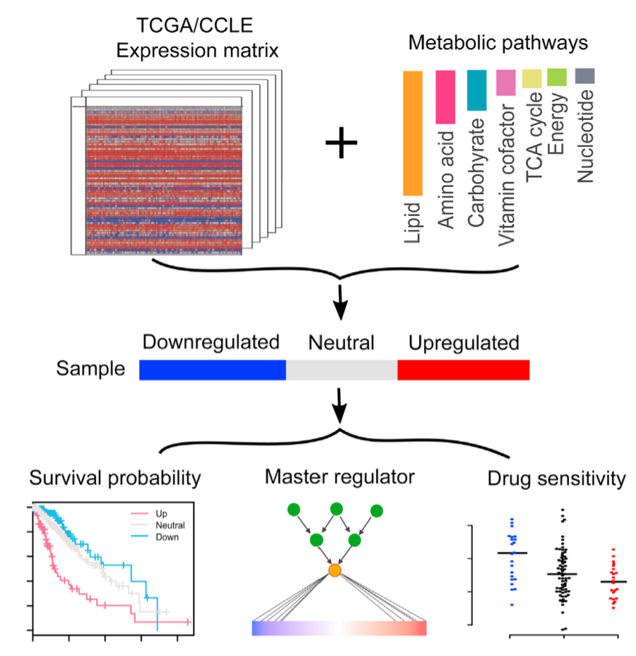Metabolic reprogramming provides critical information for clinical oncology. Using molecular data of 9,125 patient samples from The Cancer Genome Atlas, we identified tumor subtypes in 33 cancer types based on mRNA expression patterns of seven major metabolic processes and assessed their clinical relevance. Our metabolic expression subtypes correlated extensively with clinical outcome: subtypes with upregulated carbohydrate, nucleotide, and vitamin/cofactor metabolism most consistently correlated with worse prognosis, whereas subtypes with upregulated lipid metabolism showed the opposite. Metabolic subtypes correlated with diverse somatic drivers but exhibited effects convergent on cancer hallmark pathways and were modulated by highly recurrent master regulators across cancer types. As a proof-of-concept example, we demonstrated that knockdown of SNAI1 or RUNX1—master regulators of carbohydrate metabolic subtypes— modulates metabolic activity and drug sensitivity. Our study provides a system-level view of metabolic heterogeneity within and across cancer types and identifies pathway cross-talk, suggesting related prognostic, therapeutic, and predictive utility.

1. Introduction

* Prior studies focus on specific analysis of one tumor type
* Cancer metabolism bridges between oncogenic drivers and metabolic phenotypes
* Comparison of tumour and normal tissue lacks clinical relevance since both types contain very different cell compositions
* Study focused on 7 metabolic super-pathways and characterized metabolic expression subtypes in 33 TCGA cancer types

1. Results

* Curated gene sets of 7 metabolic super-pathways 🡪 largely independent from each other
  + Amino acid metabolism
  + Carbohydrate metabolism
  + Integration of energy
  + Lipid metabolism
  + Nucleotide metabolism
  + TCA cycle
  + Vitamin & co-factor metabolism
* Classification of Metabolic Expression Subtypes and Their Overall Similarity
  + Classification of tumour samples into “directional” metabolic subtypes:
  + **Normalized gene expression across samples by Z-score to obtain a rank value for each (coding) gene within each sample**
  + **Gene set enrichment analysis (GSEA) on rank values 🡪 3 subtypes (relative to ither tumours within same cancer type):**
    - **Upregulated subtype**
    - **Downregulated subtype**
    - **Neutral subtype**
  + **Assessment whether metabolic genes overall showed differential expression patterns among subtypes defined in first step**
* Checked for clinical relevance
* We found 31 associated significantly mutated genes (chi-square test, FDR < 0.05), and their associated patterns were quite diverse across cancer types (Figure 4A). The SMGs identified recurrent across multiple cancer types included TP53 (9 cancer types), PIK3CA (4 cancer types), KRAS (3 cancer types), CDH1 (2 cancer types), CTNNB1 (2 cancer types), EGFR (2 cancer types), HRAS (2 cancer types), IDH1 (2 cancer types), KEAP1 (2 cancer types), and NFE2L2 (2 cancer types).